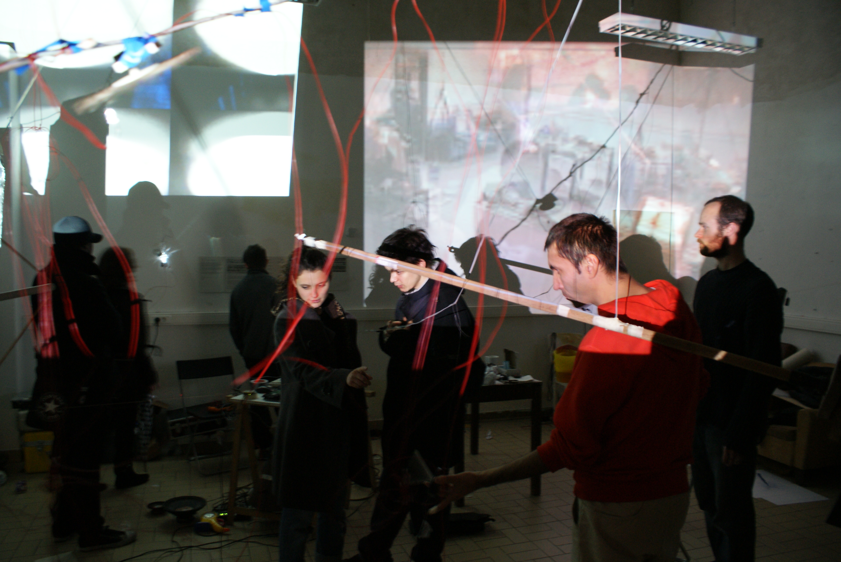

CHAOSLAB - APO33
by Julien Ottavi

CHAOSLAB - APO33

Experience #2 (HAKART): random evolution & aperiodic bifurcation

Chaotic systems are not as predominant as indeterminacy. Chaoslab creates sensitive dependences on initial conditions, devices and inputs, acting on an evolution through phase space (installation/workshop within a place) that appears to be quite random. Our Chaotic models seem to be deployed to ascertain various kinds of activities related to bifurcation points (uncontrolled steps of evolution within the workshop), period doubling sequences (or multiple sequences), the onset of chaotic dynamics proposed by the participants, the strange attractors between sources, filters, amplifications, connections and other denizens of this chaos zoo hacking behaviour.

Chaoslab amplifies the lower limit on how small changes or perturbations can be felt—the smallest of effects will eventually intensify within the whole process. This act of amplification is dependent on the nature of particular kinds of non-linear dynamics—those which exhibit stretching and folding (confinement) of trajectories, where there are no trajectory crossings, and which exhibit aperiodic orbits—these apparently open the door for quantum effects to change the behaviour of chaotic macroscopic systems.

Is CHAOSLAB a real phenomenon? Is it a static state or a current unknown space?
Aside from irregular behaviour of real-world, ie everyday life systems of maintenance, CHAOSLAB is also invoked to explain features like the actual trajectories exhibited in a given state space (piksel festival) or the sojourn times (2 to 4 days) of trajectories in particular regions of state space.

initial conditions:

a place, some spaces
some periodicities, a given duration (theoretically)
some trajectories
random bodies
machines factors
Ions
air
...

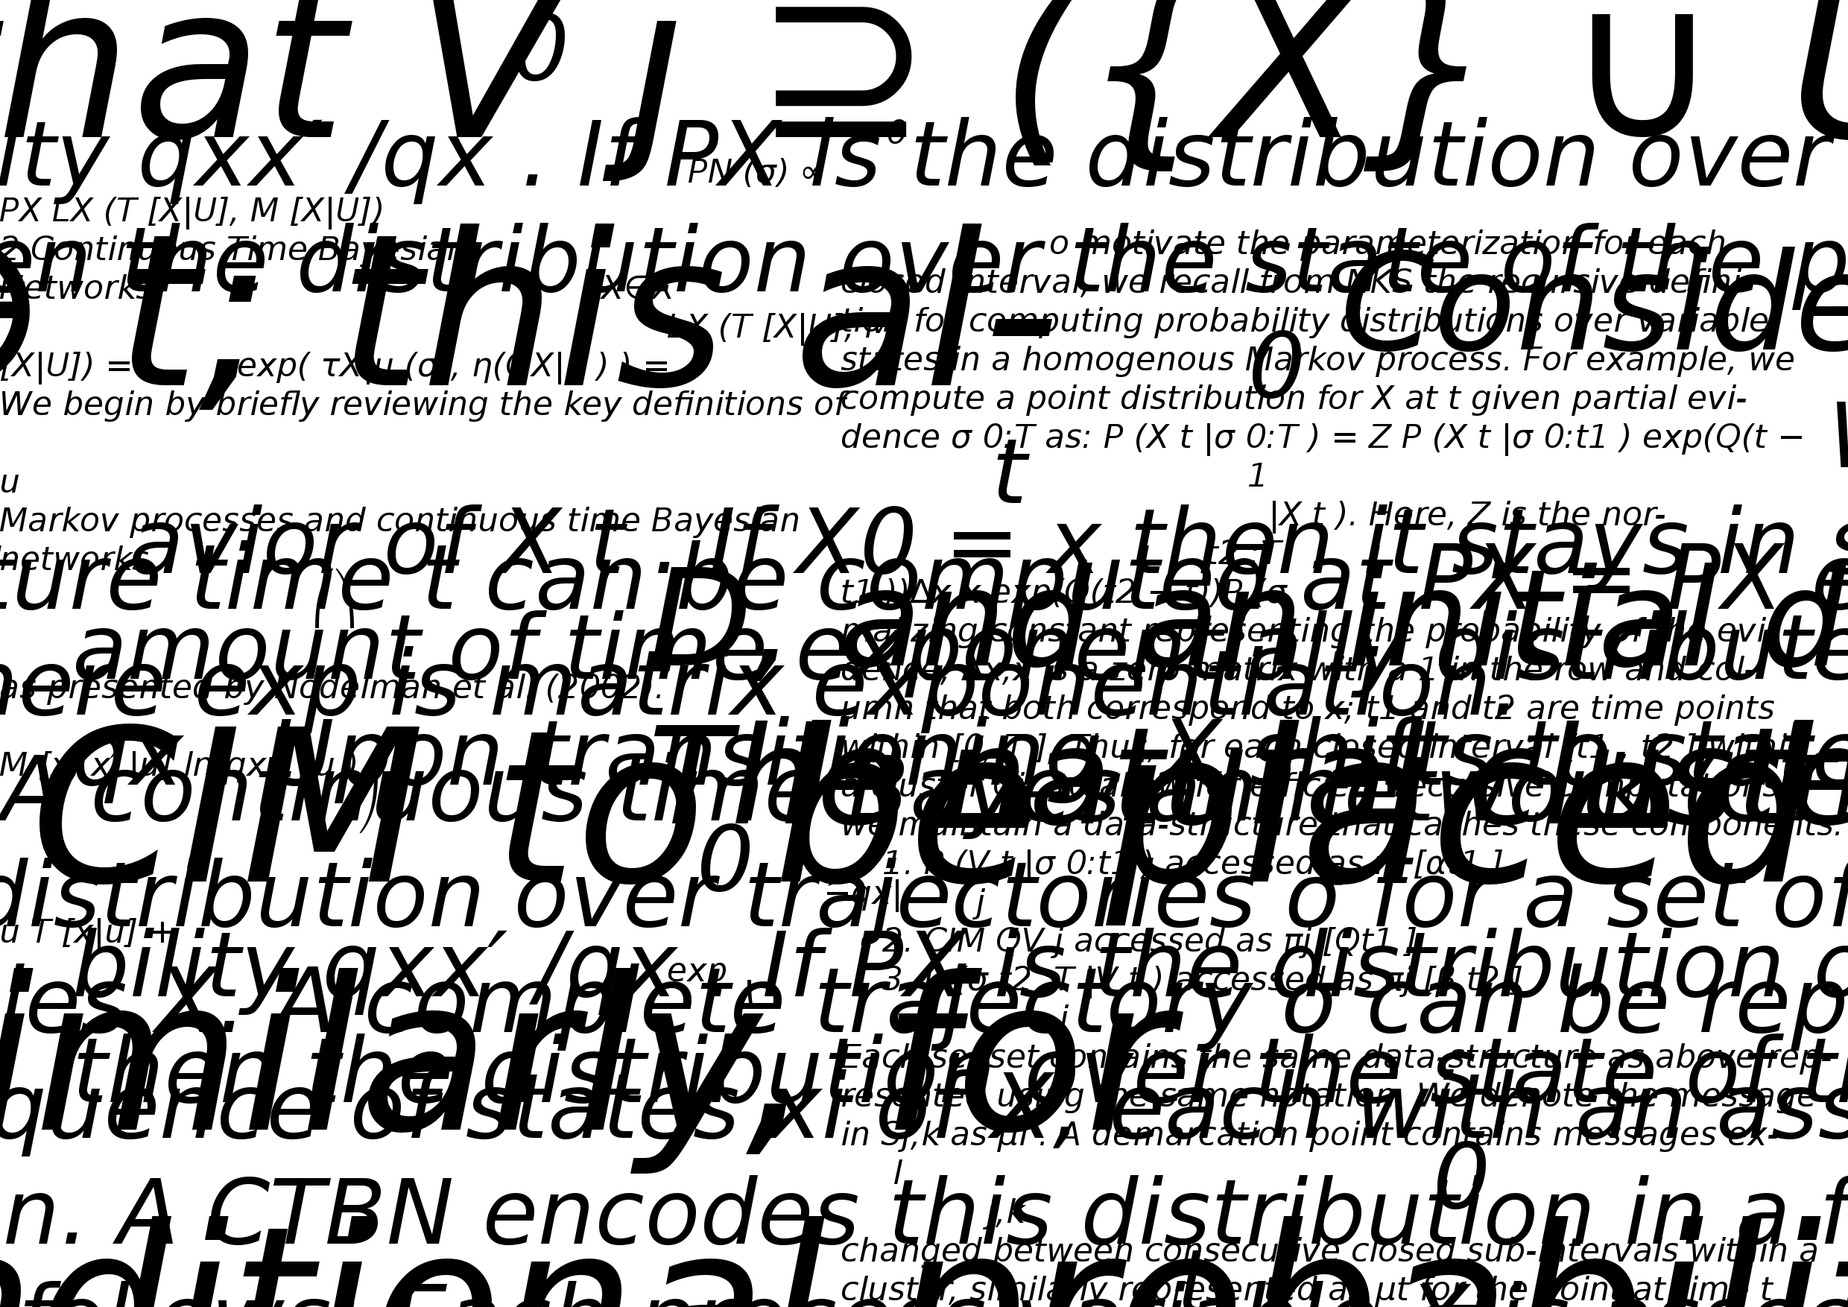

Chaos & indeterminacy

Indeterminacy, uncertainty, disorder, randomness, vagueness, fuzziness, ambiguity, crisis, indecisiveness – terms usually related to Chaos but also opposed to the concepts of order, structure and organization. Such terms appear as inseparable obstacles to the understanding of “what 's happening in here?”, and in consequence, certain or precise knowledge about things (as a non definite substance) and events (a production of action expected or not) in flux are ascertained in this artistic experiment.

Chaos is a myth develop in the ancient Cosmologies, we called it “tohu-bohu” (wrote as such in the bible for example Genesis 1:2), before existence, life - reigns chaos. From this biblical notion, could we not determine that life, thus, in its present state, is post-chaos? And that chaos reigns in this pre-formation/pre-organized plane of existence, it is through the quantum cracks, following Friedrich Nietzsche's declaration in his book The Gay Science, 1882 that “god is dead”, that chaos reveals itself? Are we not now trying to organize our chaotic predisposition? Does liberal human subject neatly file away and categorize his intellect in a well order and organized manner? What is the percentage of chaos factors on that composed our mind? And what of the soul?

We almost understand notion of chaos, if we are a living being born of chaotic materials, as we suppose here, we can no longer determine to oppose both terms – chaos and order. Conceptually they depend on the existence of each other to reinforce either state. It appears however, to escape our understanding; that even if produced in our mental imagination, we suppose chaos, something that can't be experience in its entirety, as a singular state. Whilst we could probably evaluate and define chaos within a universal entity composed of billions of frictional relations far beyond the human condition, even then we cannot be sure about what we might experience. Yet, what about the flip side of this? – An extreme state of order – This is perhaps further from our comprehension, but closer to our fears (at least those of the silent masses), due to the totalitarian visions of twentieth century dictators and various democratic governments alike.

Seeing chaos or randomness as not just a way to express some unexpected change or event but also a way to multiple the losses of regularity, as pre-organisational structure, the creation of new processes of a specific production, we have to cope with an epistemological relation to things - a non-predicable complexity.

Indeterminacy could be seen as an entangled intricacy, an undiscerning mixture of changing elements, a-periodic alteration involving different parameters and unpredictable as such. Its one scientific obsession to understand and control this unpredictability – as opposed to the arts, who rather try to harness and compose with those variations and indeterminacies.

If we had to compose a new formula for a chaotic blast (a decibel detonation) using Brownian movement based on non-mathematical sequences of sound acceleration, as the collisions of particles (speed timbre of words - code - symphony) which scheme in isolated systems – here, entropy (thought as de-measured transformations of structured movements into this a-symmetric flow of disordered time) diffuses the electronic noise burst.

What is time in indeterminacy?
We could see an event trapped in a temporal repetition – a fiction occuring at exactly the point of this events final occurrence. Stretching from position a (the first movement) to b (each repetition of a and b to infinity), it signifies an unknown position in fact. Time has moved forward and lost itself (in our conception) to grains of randomness where layers of transcendence become micro-movements as opposed to the general acceptance of the arrows of time. This passage is heavily laden with the fruits of indeterminacy revealing a forecast of predisposition and a clear mental view of the 'truth'. Time fluctuates between contrary and ambiguous machinery bending it in many direction at once, altering vision and perception of what could be eventually produce a state of the 'real'. This 'real'time is blurred randomly by unconsciousness, the foolish machine of “tromperie”, a mask of illusion here occurs, transforming and unlocking the imagination – the dealing place of a fiction of permanently altered states.

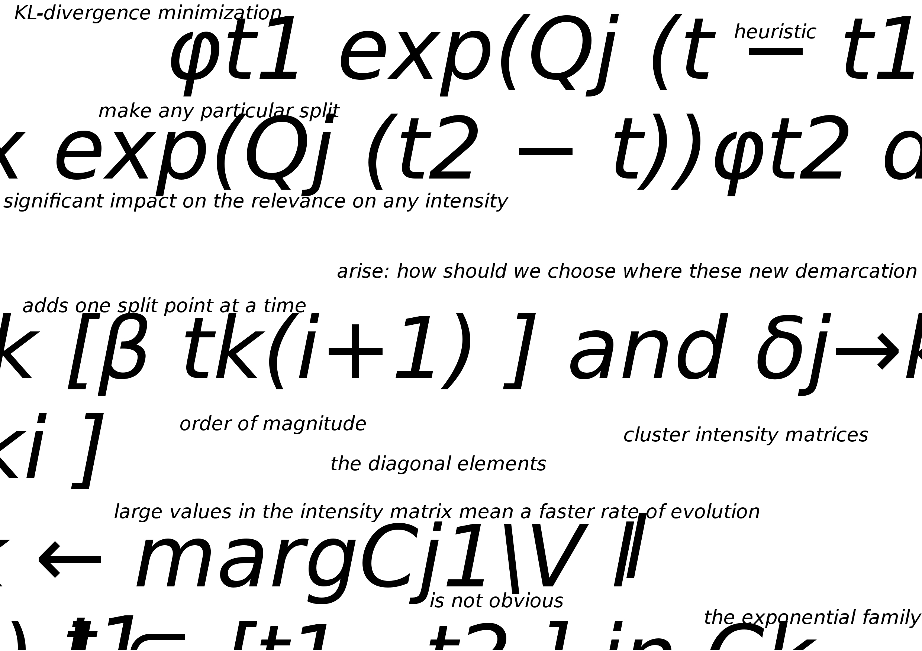

Strange attractors and the chaosmatic experience

Strange attractors set the limits of our chaosmatic trajectory, an attractor that is topologically distinct from the periodic accumulation of blended perception or a limited cycle of noise (a non analysed transfer of pure energy) which may then be considered as a fractal attractor. Consider a place in shift-phase space, defined by those initial conditions composed within a dissipative system, this space will shrink as the noise evolves in time, which in turn will create random trajectories that are no longer in direct relation with those initial conditions. We evolve through a sensitive set of attractors embeded in multi-fractal conditions, the trajectories of the contradictory points re-introduce these unexpected conditions before moving apart in some random direction (non-predicable). closer in others, but there will be a net shrinkage witthin the place, all physical forms of life will feel this phantasmagoric emulation of senses . Ultimately, all convergent points will lie along a fine line relative to the limits set originally by the attractors. The strange attractor. All the possessed bodies will shift-phase in the space and then land on the attractor forming in chaos. This sudden movement of the strange attractors results, when sensitive fractal conditions are not conservative, ie not only internalized and isolated. Engendering a delirium of repulsive shrinking in space, displaced, (lost?) in various layers of time.
Because of extreme dependence on initial conditions, the general rule for a chaotic experimentation is that one cannot create a model that will accurately predict outcomes. None of them have the ideal conditions to even approach a draft of a total 'chaosmosis'. It demonstrates that no matter how close conditions start out, or wherever they take place, after a few iterations, minor differences will be blown way out of proportion changing the different direction that has been taken from the beginning of the experience. The points will then separate from each other at an exponential rate, transforming the places in a complete a-differential stretch of perceived times . A very tiny “error” in the initial conditions makes a very large difference in the outcome. And we probably reverse the process into his extreme opposite, thus by introducing those tiny errors in the initial conditions themselves.

Our Chaosmatic experience could be summarize in two contradictory elements:
- Chaosmatic is non-deterministic. Meaning no determining equation or rule dictates behaviour. Mathematics does not apply. Chaosmatic is dislocated from any logical explanation. Chaosmatic is non-predictable in their inner-materiality. Chaosmatic is almost random, nearly disorderly. Is random experience chaotic? Is chaos has a sense of order and patter?
- Chaomosis is sensitive to initial conditions but not only, it is also open to the accidental or indeterminacy that may occur. Chaosmosis takes into account any slight change from the starting point as well as following changes of conditions - this can lead to significant differences in the outcomes.

Chaoslab as an experimental tohu-bohu situation

To come in a present time (if such notion could exist really), no sooner experienced than it is already dispersed, or un-fleshed in an accumulation of memories - Chaoslab welcomes all types of divergent time, noise and light colliding with each other from the outset of its initial conditions. Chaolab creates random fractures through exponential rendering onto a space, forcing a shrinkage in the perception of the place. A congregate of electronic circuits, blast across the architecture through the amplified feedback of transducers – bass implosions and stroboscopic hallucination, cut-up language and sequencing in a maelstrom of electromagnetic physical mutations. Chaoslab is searching for a quantum ubiquity, a frozen time in which everything escapes the tangible, eludes our preordained controls and cheats our deterministic inhuman condition. An inverted cycle develops to define a chaotic model in the universe amongst our everyday life activities. The Chaoslab tries to approach these questions in the various composition of the labs fundamental components, but also though a sensitive position towards our machines of perception. Chaoslab is expanding, using minimal changes as a potential for a re-creation of languages - starting from experience and “savoir-faire” of everyone involved in the process (participants from the different level of action). We are not seeking an answer or to define a 'truth', but organise a framework where we will de-construct our own habits, comprehension and mechanism for “making”. It may not bring satisfaction, nor be far from a perfection, or even a clear articulation of thoughts but at least it will always bring about a state of chaotic production of noise and of light, changing the paradigm of a space (the writing of a place) through altered random fiction and unexpected results.

Acknowledgement
thank you Jenny Pickett for conversation about chaos & time that contributed towards parts of this text.



